APAConnect Manual  
for Super Users & Administrators

Uice Lu, developer. June 2014

# Purpose Description

This is a manual for super users or developers of the portal, to maintain users, content structures and theme layout.

# System Base Info

## CMS

APAConnect is built on a famous open source CMS system called WordPress. We have been keep up-to-date and the version is 3.9.1 when this manual is being written.

WordPress is originally a blog system. However, it has greatly developed these years, and become a complete & strong CMS system. With variety of resources including themes and plugins online, and tons of trouble shooting discusses in communities, we can build nearly any website with it.

WordPress provides a powerful admin panel for authors to write, create, even forget they are in a browser, and also with the support of a media library, we can do bulk drag & drop uploading files.

WordPress supports extensions or customizations in 2 ways: themes and plugins. Basically, both of them are php code extends the WP core. WordPress prepares countless hooks called ‘action’s and ‘filter’s, which makes it possible to extend the WordPress, without touching any code of the core.

## Environment

WordPress is written in php, it requires a ‘XAMP’ environment. The ‘XAMP’ are: X, operating system including Windows, Linux and Mac OS; A, Apache web server, or nginx web server (or IIS on Windows); M, MySQL database; P, php runtime binary.

Here’s a version list of these dependencies.

|  |  |  |
| --- | --- | --- |
| Dependency | Required Version | Product Version Uses |
| Operation System | Windows 7+ or Linux | Ubuntu 12.04 Server (Linux) |
| Web Server | IIS7+, Apache 2.2+ or nginx | Apache 2.4 |
| Database | MySQL 5.0+ | MySQL 5.5 |
| php runtime | php 5.3+ | php 5.5.11 |

## General Configuration

Here’s how we can reinstall the whole environment of APAConnect.

### Operating System

Install one of the operating systems and enable the 80 port, which web server needs to listen to.

### Web Server

If we use Windows Server. We just enable the IIS feature.

If we use Debian / Ubuntu, we run ‘apt-get install apache2 mysql-server php5’.

We should enable ‘.htaccess’ file support for url rewrite.

Bind the domain to the code folder in web server. For the moment, domain is ‘apaconnect.fiat.chrysler.com’, folder is ‘/var/www/’. For code setup, please refer ‘Code Base’ section.

### MySQL

If we use Windows, we need a separate installation package of MySQL from Oracle’s website.

If we use Debian / Ubuntu it’s already installed in the last step.

When done, we need to setup a specified database account for the portal, for security and standardization.

Import the backup portal database. And make sure that the first ‘meta_value’ in ‘wp_option’ table is the site url we would like to use.

### Php

If we use Windows, we need a separate binary package from php.net.

For product version, make sure that ‘display_errors’ is turned off.

For php 5.3, remind to set ‘short_open_tag’ to ‘on’.

### WordPress

Normally, WordPress would install itself. If you’d like to do it manually, just copy ‘wp-config-sample.php’ to ‘wp-config.php’, and change database info in it with the one you’ve setup in MySQL.

We need to log onto admin panel > settings > permalinks, chose ‘Post name’ under common settings and save, to generate an ‘.htaccess’ file, to make url rewrite works.

## Code Base

Code of APAConnect repository is saved at [*https://github.com/uicestone/APACPortal*](https://github.com/uicestone/APACPortal). It’s open sourced, following the WordPress license. However, we didn’t share anything credential. Database configuration, data and media file such as images and videos are marked in .gitignore file, and are not included in the repository. They are stored in product server only, under daily internal backup.

The development of APAConnect is mainly the development of the theme ‘apacportal’, located at /wp-content/themes/apacportal. A WordPress theme not only defines the layout of a website. It’s actually a group of php code extends the WordPress core, changing or adding functions for the CMS when this theme is activated. In our theme, the /wp-content/themes/apacportal/functions.php filecontains php code that makes use of the WordPress hooks.

# Panel Menus Overview

Here’s an overview of admin panel menus. Posts, media, comments and links are basically user generated content (UGC), among them, ‘links’ is a custom post type we have in APAConnect.

## Pages

‘Pages’ is one of the main parts throughout the APAConnect website. In it, we can create ‘page’, for a department, for an activity, or even global level page like ‘Home’, ‘Work’, and ‘Life’. We customize and style each page by typing shortcode in it, which we’ll talk later in “The Dynamic ‘Box’ System” section.

For what kind of contents can be ‘page’, go to ‘Content Structures’ section.

For how to customize pages using shortcodes, go to “The Dynamic ‘Box’ System”

## Appearance

Items ‘Appearance’ menu controls the site’s layout, and more.

In ‘Themes’ child item, we can easily change to another theme, located in /wp-content/themes/.

‘Customize’, nothing else, but we can change the static front page here. We now defined page ‘Home’ as our home page. Actually we can define any ‘page’.

‘Menus’ and ‘Widgets’ are important part we’ll mention below.

‘Editor’ menu gives us a possibility to modify any code under the theme directly without an IDE. It’s save to change any code here temporally. We can recover anything by ‘git’ version control on the server. Check ‘Code Base’ or ‘Template Hierarchy’ section to learn which file should we edit.

## Plugins

Install and controls status of plugins. Also we can build our own plugins as extension. See ‘Plugins’ section.

## Users

Add, modify and delete users or the CMS system. ‘Users’ in APAConnect includes administrators, maintainers and anyone that could be found in People Finder. See ‘Users & People Finder’ section.

## Tools

Import and export tools are built in WordPress. Howerver we don’t need this because we have setup an automatical daily backup on Ubuntu server by ‘cron’ job.

## Settings

In ‘General‘, we can set and change the site URL in case we need.

In ‘Permlink’, make sure we have checked the ‘%postname%’ option to have nicer URLs for our posts and pages.

In ‘Reading’, we can set search engine visibility, to control whether APAConnect is open for any indexing service (like our gsa-crawler service in Italy).

# Content Structures

## Post & Post Type

WordPress stores most of the contents as ‘post’, which is a wide conception, including blog posts, pages, attachments, menu items or custom content like links as we defined.

The post, page, attachment, menu_item and link are called Post Type.

Below in this manual, we define WordPress ‘post’ in its specific conception, which refers to blog posts, or articles.

A URL to a post page would be SITE_URL/POST_NAME/.

## Categories and Tags

We have posts divided by ‘categories’. ‘Category’ in WordPress is the default taxonomy to classify posts. We have extended the ‘category’ taxonomy to ‘attachment’s and ‘link’s too.

Our category is a tree like.

Home

Departments

- Department Name

- Department Particular Categories

Market

- Market Name

- Market Particular Categories

Travel

Training

Quick Link

Notices

Annoucements

How To

Events

Forms

Policies & Progress

Anyone who publish a post, link or media, would check either ‘Home’ or one of the Department Names, to claim that this piece of content should be displayed globally or in a department scope. Then, they check a category best matches the content.

For example, an HR policy post or attachment would be published with ‘HR’ and ‘Policies & Progress’, while a APAC News would have categories like News, Home and Cummunication.

A URL to a category archive page would be SITE_URL/category/CATEGORY_NAME/.

A URL to a tag archive page would be SITE_URL/tag/TAG_NAME/.

Specified tag or category archive page can be totally rewriten by template file. See ‘Template Hierarchy’ section.

## Media & Links

Media (AKA Attachment) is another post type in WordPress. It was designed to be attached to posts. But in APAConnect, we can assign categories and tags directly to attachments. And they would thus be displayed in any post list, equivalent to normal ‘post’s.

Link is a custom post type we created for APAConnect. We should put a link text in its Title text field, and the link href (usually starts with http://) in the Content area. It can also be tagged and categorized.

## Pages

Home, Work, Life, departments pages and event pages are all controlled by ‘Page’ post type. They’re place holders to invoke and display relavant post lists orgnized as ‘box’es. We can type HTML content directly in pages, and also use the “Dynamic ‘Box’ System” short code to invoke dynamic contents.

A URL to a ‘page’ would be SITE_URL/PAGE_NAME/.

Pages can also be completely rewriten by template file, see ‘Template Hierarchy’ section.

## The Dynamic ‘Box’ System

In order to separate ‘program’ and ‘content’, avoiding frequently code editing when we need change page content, we developed a dynamic ‘box’ system.

A ‘box’ here, is a wording of content unit invokable in ‘page’, regardless its style. We made use of WordPress shortcode function. For example if we want to display a list of some category, instead of writing php code, we just type

[box title=”TITLE” category=”CATEGORY_NAME” /]

in the Content area of a ‘page’.

Most used properties are:

title: the box title. If not specified, this is a box without header.

category: a shortcut for category_name. For filtering posts, all attributes in WordPress WP_Query class is available here. See [WP_Query arguments](http://codex.wordpress.org/Class_Reference/WP_Query).

type: 3 quick types are defined: list, single and slider

class: box css class, no-padding, no-min-height, no-margin-bottom, ellipsis are available

content: if set to ‘none’, this is a box without content section.

The completed documentation of these shortcodes can be found at [*https://github.com/uicestone/APACPortal/blob/master/wp-content/themes/apacportal/functions.php*](https://github.com/uicestone/APACPortal/blob/master/wp-content/themes/apacportal/functions.php).

# Appearance

## HTML & CSS Base

‘Apacportal’ is a WordPress child theme of ‘Twenty Twelve’. However, we didn’t inherit the css part of the parent theme. Also, we’ve rewrite most of the HTML part by ‘Template Hierarchy’. The only thing we reversed from ‘Twenty Twelve’ is some fragmentary part like error page template, search result template and so on.

‘Apacportal’ theme is powered by Twitter’s Bootstrap project. To have a better compatibility with Internet Exporer 8, we use the legacy Bootstrap version 2.3.2. Our nav menus, buttons, forms and tables are automatically styled. Our page layout are controlled by Bootstrap’s scaffolding system. We implement it into ‘column’ short code, so we can have any page with ratio divided from 12 columns (eg: 3:9, 3:6:3, 4:5).

In additon, with limited development, we can use any templates based on Bootstrap in the future.

## Template Hierarchy

The Template Hierarchy system of WordPress tells us where to put our code when we wants to completely customize our page.

Here’s the Hierarchy.

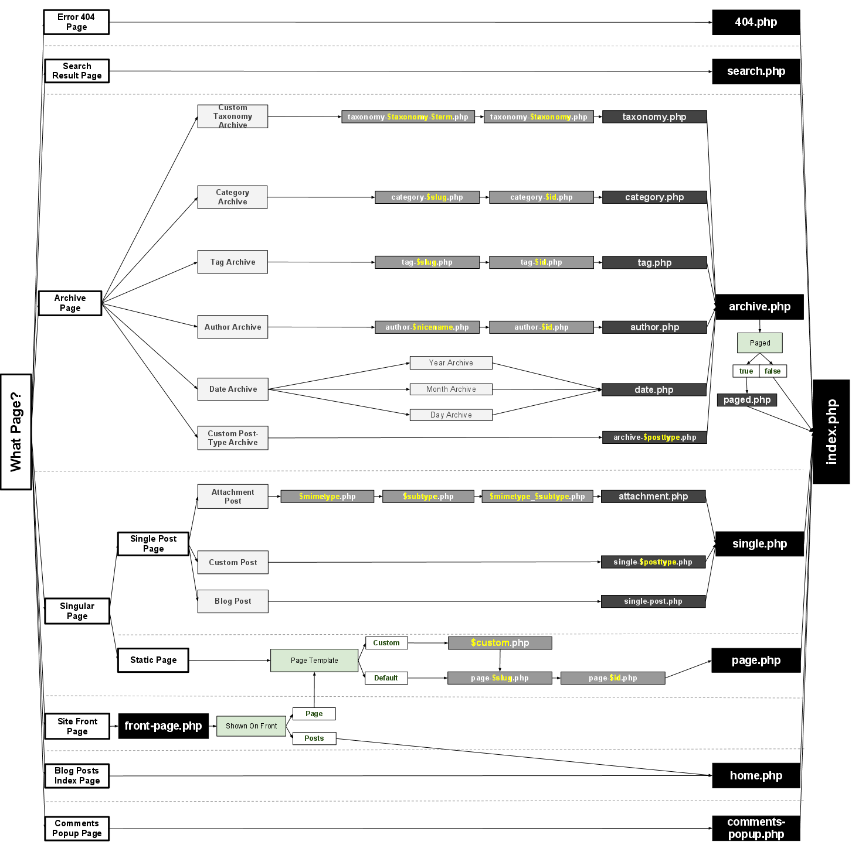

## Core Function Overview

## Menus

In Appearance > Menus of admin panel, we can change the current main (and other) menu items, just by drag & drop. Menu items can be page, category or whatever custom link want.

Also, we can register new nav menus by calling register_nav_menu() in function.php, ‘init’ action, edit them in admin panel, and invoke them in template files like header.php or footer.php by calling wp_nav_menu().

## Widgets

In Appearance > Widgets of admin panel, we can define a global container called Widget Area, for example, the Left Sidebar. Then we can put widgets into it. Among the built-in widgets, we have developed 2 of our own: People Finder and Post List. We can than drag them into the Left Sidebar Widget Area, and invoke it by calling the [sidebar id=”WIDGET_ID”] shortcode in a page (eg: the ‘Life’ page).

# Users & People Finder

## User Roles

Administrator: super user who have the full admin panel permission, including install and active plugins, change themes and maintain users.

Editor: content leader who can publish, edit, delete any post in the portal.

Author: users who can publish his own content, unable to edit others.

Contributer: users who can write content, but cannot publish until an editor helps him.

Contact Editor: our custom user role, who can upload and delete people in the same company with him.

## People Finder Maintanence

# Statistics

## Post & Page Views

## Views Count by Country

## Advanced Statistics

# Plugins

## BAW Post View Count

## Disable Google Fonts

## FancyBox for WordPress

## Hansel & Gretel

## JS & CSS Script Optimizer

## Manual Image Crop

## MCE Table Buttons

## PHPExcel

## Pretty File List

## Quotes Collection

## Rich Text Excerpts

## WP Better Attachments